**OverTheWire Bandit - Level 8 to Level 9 Writeup**

**Introduction**: This writeup documents my experience solving Levels 8 to 9 of the OverTheWire Bandit challenge, a CTF-style game focused on learning about security concepts.

**Author**: Misha Jain

**Date**: October 19, 2023

**Tools Used:**

Terminal (SSH client)

**Challenge Description:**

Level 8 to Level 9 of Bandit involves connecting to a remote server via SSH and finding a password stored in the file "data.txt" with specific properties.

**Enumeration:**

For Level 8, we need to connect to the server using the credentials we obtained in Level 7. Our goal is to find a password stored in the file "data.txt," and it is the only line of text that occurs only once in the file.

**Exploitation - Level 8:**

To connect to the server for Level 8 using SSH, we use the provided credentials:

ssh bandit8@bandit.labs.overthewire.org -p 2220

Use the password obtained from Level 7, which is TESKZC0XvTetK0S9xNwm25STk5iWrBvP to gain access.

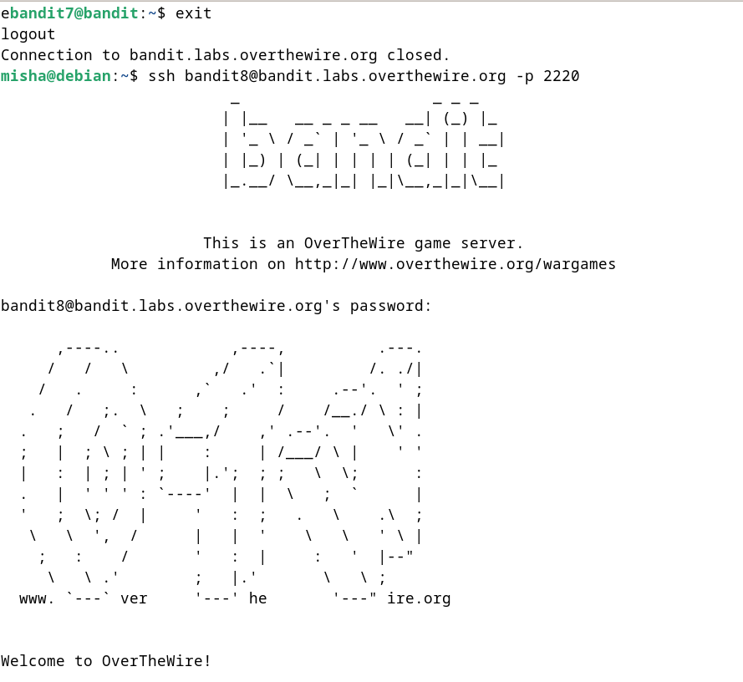

**Password Retrieval - Level 8:**

The password for Level 9 is stored in the file "data.txt," and it is the only line of text that occurs only once. To check the contents of the data.txt file, we can use the cat command.

cat data.txt

To find this line, we can use the sort and uniq commands together to filter out lines that occur more than once.

sort data.txt | uniq -c

The sort command is used to sort the lines of the file "data.txt" in ascending alphabetical order. By default, sort treats each line as a separate unit of text and sorts them accordingly.

uniq -c: The uniq command is used to filter out adjacent, duplicated lines and only show unique lines. The -c option is used to count and prefix each unique line with the number of times it appears.

These commands will display the Level 9 password.

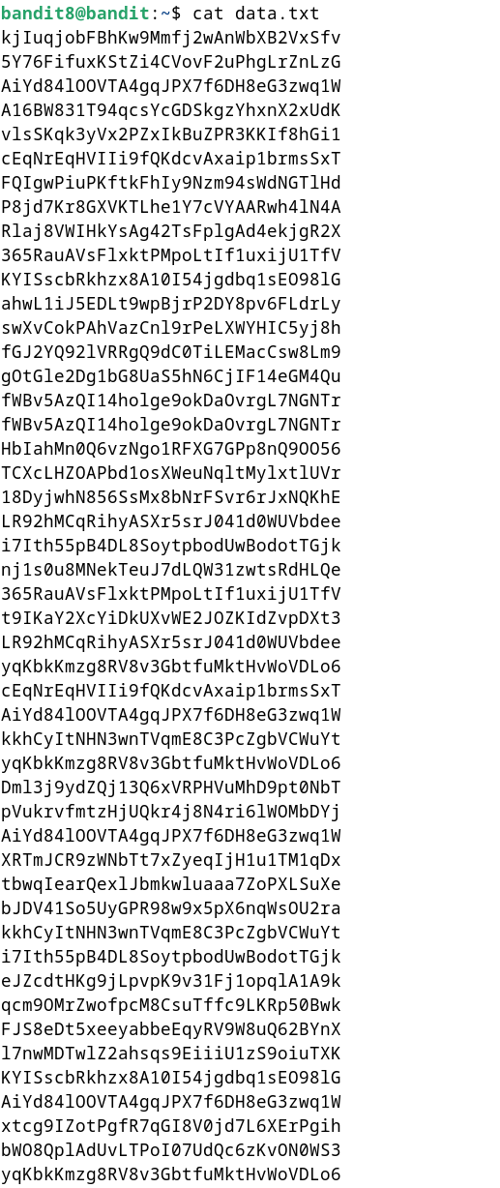

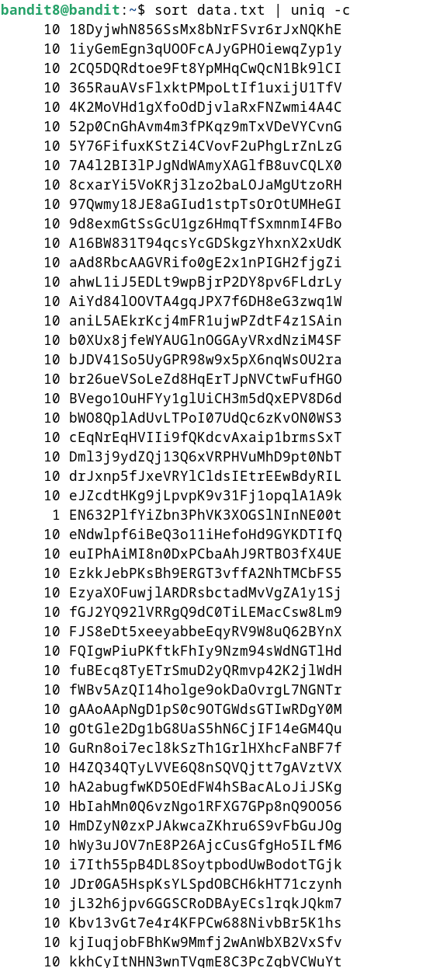

**Password – Level 9:**

The password for Level 9 is: EN632PlfYiZbn3PhVK3XOGSlNInNE00t

**Exploitation – Level 9:**

Now that we have the Level 9 password, we can connect to the server for Level 9 using SSH:

ssh bandit9@bandit.labs.overthewire.org -p 2220

Use the Level 9 password to gain access.

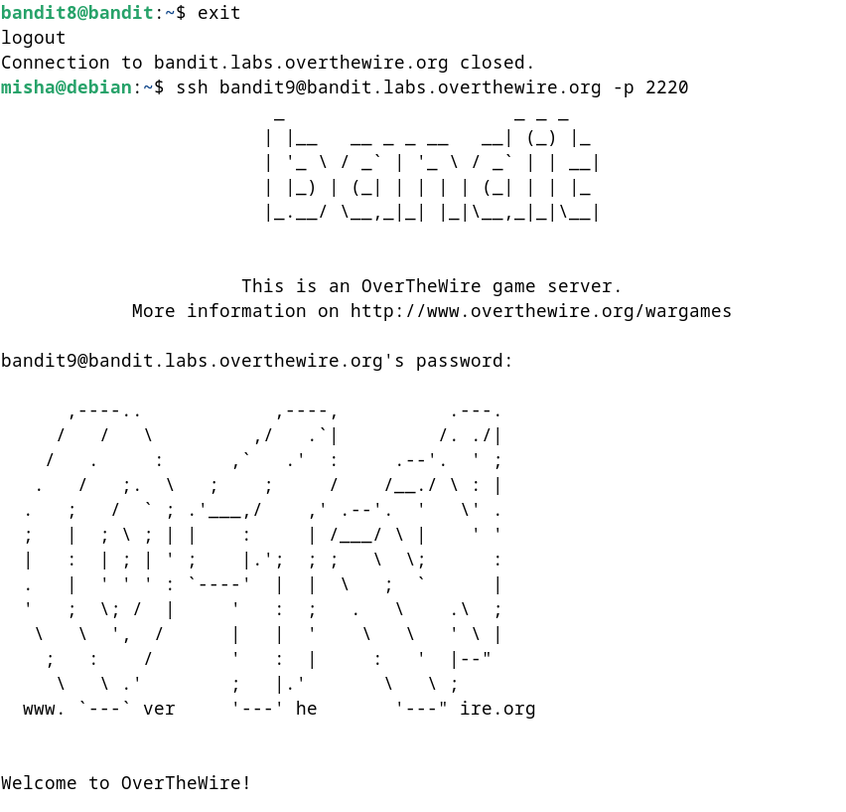

**Lessons Learned:** Level 8 to 9 introduced us to using the sort and uniq commands to filter out unique lines from a file. This level reinforced the use of basic file handling and text processing commands.

**Conclusion:**

Levels 8 to 9 of the OverTheWire Bandit challenge continue to build on shell command knowledge while introducing new challenges involving text processing and finding unique lines within files. These levels are suitable for beginners to learn more about file manipulation and data analysis.